RESTAURANT ORDER
Power Bi Project Report

- Project Overview:
This project focuses on analysing restaurant order data by performing data cleaning in Excel and creating interactive dashboards in Power BI. The dataset was processed to remove inconsistencies, standardize formats, and ensure data accuracy before visualization. Power BI is used to present key insights on sales performance, order trends, and menu analysis.
- Project Objective:
The objective of this project is to analyse restaurant sales data to identify revenue trends, peak order times, and top-performing menu items. By combining Excel for data preparation and Power BI for visualization, the project aims to support data-driven decision-making and improve business performance.
- Data Sources:
- Source Description and Timeline: Free Sample Dataset Download - Restaurant Orders - Maven Analytics | Build Data Skills, Faster and 2023
- Domain: Retail - Restaurant / Food Industry

- Problem Statement:
- To analyse restaurant sales performance to identify revenue trends and overall business growth.
- To identify top-performing and low-performing menu items for better menu optimization.
- To study peak order times and customer ordering patterns to improve operational efficiency.
- To evaluate category-wise performance to understand which food categories generate higher sales.
- To understand customer purchasing behaviour to support better marketing and promotional strategies.

- Attribute Details:
Attribute Name | Data Type | Description
order_details_id | Integer | Unique ID for each order item record (primary key)
order_id | Integer | Unique ID for each order (one order can have multiple items)
order_date | Date | Date when the order was placed
order_time | Time | Time when the order was placed
menu_item_id | Integer | Unique identifier for each menu item
item_name | Text (String) | Name of the food item
category | Text (String) | Category of the item (e.g., Food, Beverages)
price | Decimal/Float | Price of the item

- Tools & Technologies:
- Excel: Data cleaning, transformation
- Power BI: Data modelling, DAX calculations, visualization, and interactive dashboard creation.

- Data Pre-Processing (Excel / Power query):
Task Performed
- Data Cleaning & Transformation: Removed duplicates, handled missing values, standardized formats, and created calculated fields.
- Pivot Tables: Generated Pivot Tables for data summarization and initial insights.

- Data Modelling and DAX (Power BI):
- Data Model: Established relationships between tables in Power BI, defined appropriate cardinality, and created lookup tables to ensure efficient data modelling and accurate analysis.
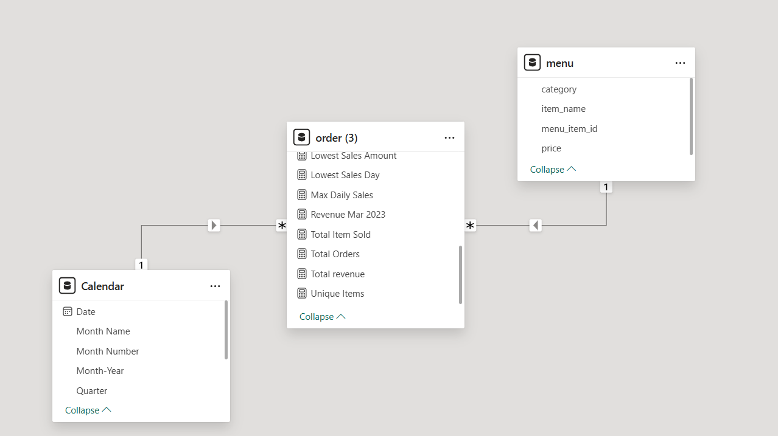
- Calculated Columns & DAX Measures: Utilized DAX to build dynamic measures such as total revenue, order count, item sales, and previous month sales to support data-driven decision-making.

DAX Function Definition:
- Total Revenue
This measure calculates the total revenue by summing up the price column from the orders table using the CALCULATE function.

- Category Rank
Ranks categories based on total revenue in descending order. Helps identify top-performing categories.
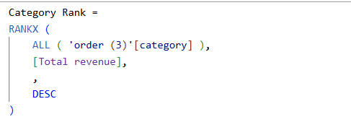

- Revenue Mar 2023
This measure calculates the total revenue for March 2023 by applying specific filters on year and month from the Calendar table.
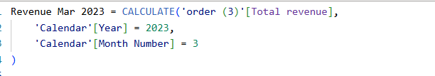

- Highest Sale Date
This measure identifies the date on which the highest sales occurred by comparing total revenue across all dates.
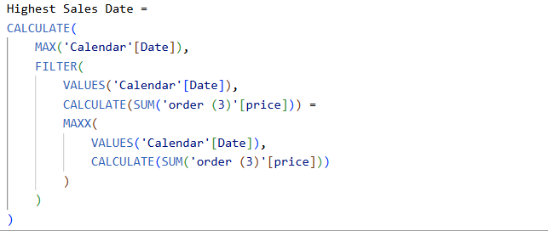

- Menu Item Rank
This measure ranks menu items based on total revenue by removing filters using ALL and applying the RANKX function.
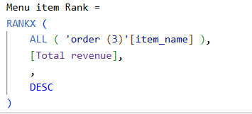

- Growth %
This measure calculates the month-over-month growth percentage by comparing current month revenue with the previous month.
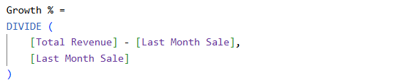

- Order Time Category
This calculated column categorizes order time into different periods such as Morning, Afternoon, Evening, and Night based on the hour value.
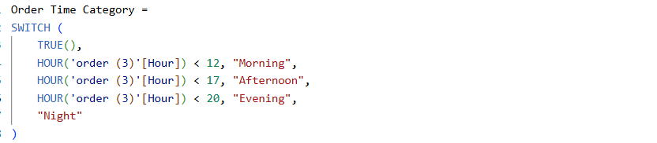

- Analysis and Visualizations (Power BI)

Dashboard Features
- Interactive Dashboard: Designed with user-friendly navigation, enabling dynamic exploration of restaurant sales and order data across multiple dimensions
- KPI Cards: Display key metrics such as Total Revenue, Total Orders, Total Items Sold, Growth %, Last Month Sales and Average Order Value (AOV)
- Line Chart: Shows revenue trends over time (Year, Month, Day), helping identify sales patterns and growth
- Donut Chart: Represents revenue distribution by category, showing percentage contribution of each category
- Time Analysis Chart: Analyses order distribution by hour to identify peak ordering time and customer behaviour
- Table: Top 10 items analysis displays the top 10 menu items ranked based on total revenue, helping identify best-performing products
- Monthly Revenue Analysis: Calculates total revenue separately for January, February, and March to compare month-wise performance
- Sales Extremes Identification: Identifies the highest and lowest sales dates along with their corresponding revenue to highlight peak and low-performing days
- Tooltips & Data Labels: Provide additional insights and clarity on visuals for better understanding
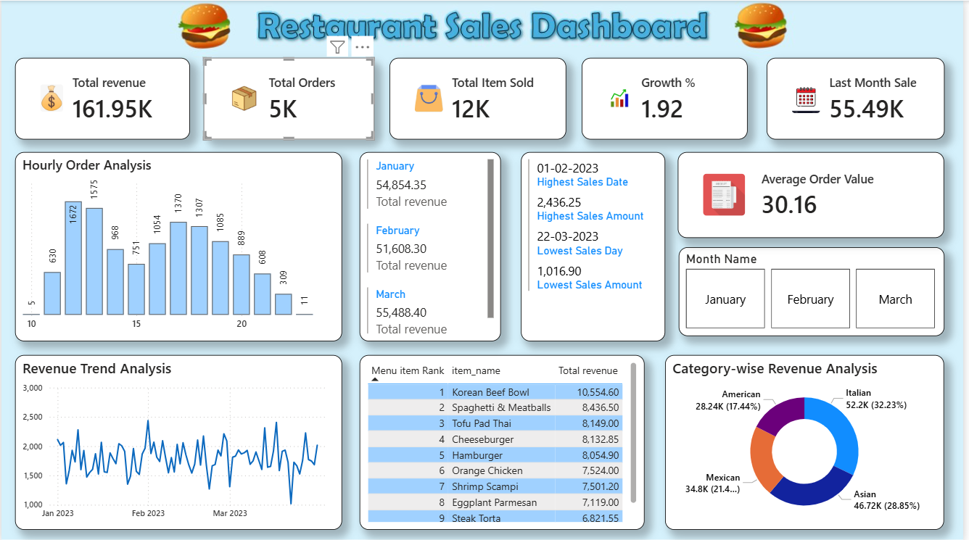

- Insights & Conclusions:

Key Findings:
- Overall revenue reached 161.95K, showing steady growth
- Higher number of orders observed during evening hours (peak time)
- Top items such as Korean Beef Bowl and Spaghetti contributed significantly to revenue
- Italian and Asian categories hold the highest revenue share
- March generated the highest revenue among all months
- Certain dates showed low sales performance, indicating potential improvement areas

Analysis Insights:

  - Descriptive Analysis (What happened?)
- Total revenue, total orders, and items sold were clearly measured
- Month-wise revenue comparison (January, February, March) was performed
- Hour-wise order distribution helped identify peak ordering time
  - Diagnostic Analysis (Why did it happen?)
- Higher orders in the evening indicate increased customer demand during that time
- Top-performing items generated more revenue due to their popularity
- Category analysis shows that only a few categories contribute the majority of revenue

  - Predictive Analysis (What is likely to happen?)
- Evening peak sales are expected to continue in the future
- Top-selling items will likely maintain high demand
- High-performing categories will continue to drive overall revenue

  - Prescriptive Analysis (What should be done?)
- Increase staff and stock availability during peak evening hours
- Introduce promotions or combo offers for top-selling items
- Provide discounts or offers on low-performing days to boost sales
- Focus on expanding high-performing categories in the menu

Conclusions:

The dashboard highlights strong sales performance, clear peak hours, and key revenue drivers, enabling data-driven decisions to improve business performance and customer engagement.

